*Florida International University*

*School of Computing and Information Sciences*

Software Engineering Focus

Feature Document

User Story ID <Access the local database>

**Name:Bertha M Perez**

**Frank Hernandez**

**Team Member(s): Bertha M Perez**

**Frank Hernandez**

**Project: Snackability 1.0**

**Product Owner(s)**: Dr. Cristina Palacios

**Mentor(s)**: Dr. Cristina Palacios

**Instructor**: Masoud Sadjadi

**User Story Name:** Access the local database

### Description:

* As an User I would like to be able to look for snacks located on the FIU vending machines so that I can get a score

### Acceptance Criteria:

1. Be a registered user
2. Enter a Snack

|  |  |
| --- | --- |
| Use Case Name: Search for Snack | |
| Participant Actor: User | |
| Entry Condition:   * User must be log in * User want to search for a new snack | |
| Exit Condition: User get a score and feedback for the snack entered | |
| **Flow of Events** | |
| **Actor Steps** | **System Steps** |
| 1. User enter information about a snack  5. User select the correct Snack | 2. System search for the snack.  3. System return a list with all the snacks found  4. System show the list of snacks to the user  6. System request snack information  7. Database return snack information  6.System calculate score and show the user the information |
|
| **Use Case Exceptions** | |
| **Actor Steps** |  |
| 1. User enter information about a snack [snack not found] | [Snack not found]  System indicate that there is not result for this search and offer option to search for a new snack |

**Use Case Diagram <**you can use draw.io**>**

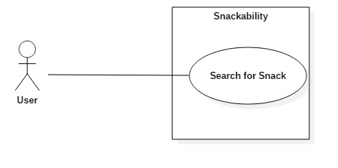

**Sequence Diagram**

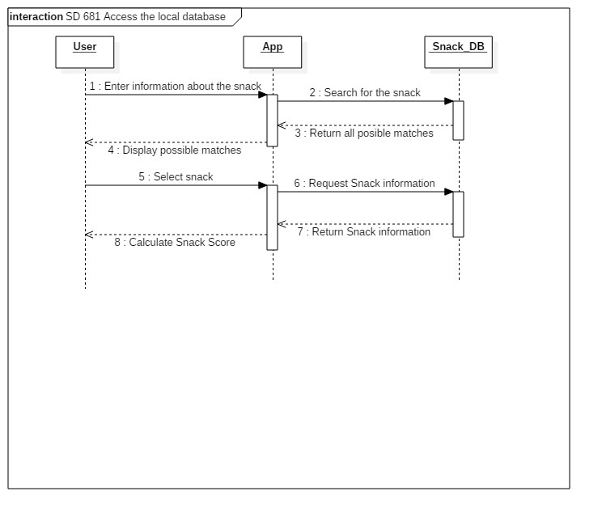

**Class Diagram**

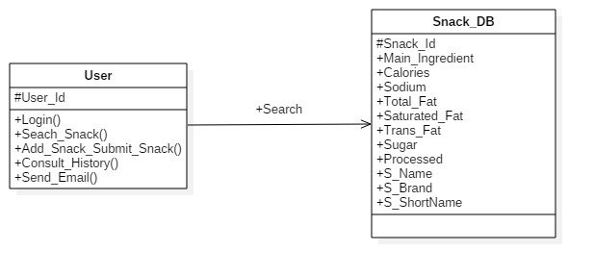

**Unit Test**

* Test case ID: look_for_snack_ID
* Description/Summary of Test: Given a snack and serving size when the user select Search, then the server should return snack detail page
* Pre-condition:
* Expected Results: Server return snack detail page
* Actual Result: Snack detail page returned
* Status (Fail/Pass): Pass

**Integration Test**

**Visual User Guide** <like one or two screenshots of the feature. For the hardware project, a photo of device is required>